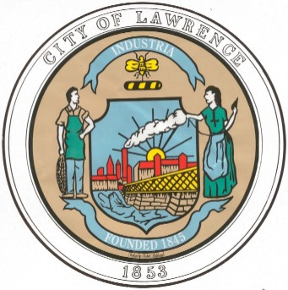CITY OF LAWRENCE
Office of Assessors
City Hall * 200 Common Street * Lawrence, MA 01840
Tel: (978) 620-3190 www.cityoflawrence.com
Alexcy Vega, MAA
Chief Assessor
Maria A. Halloran, MAA- Assessor
Aimee Valdez, M.Ed- Assessor
Brian A. De Peña
MAYOR OF LAWRENCE

Avoid Potential Motor Vehicle Excise Penalties, Interest and Fees

The Lawrence Board of Assessors has issued this message trying to get the word out about your 2024 motor vehicle excise tax bill.

Under Massachusetts General Law Chapter 60A, all Massachusetts residents who own and register a motor vehicle must annually pay a motor vehicle excise. While individual communities bill and collect these excise taxes, it is the Registry of Motor Vehicles (RMV) that compiles all the information you see on the bill, according to the information on the motor vehicle registration. It is important to note that every motor vehicle, whether registered or not, is subject to taxation, either as excise or personal property, for the privilege of registering a motor vehicle.

The City of Lawrence issued the calendar year 2024 motor vehicle excise (1st Commitment) on Thursday, February 22nd. Payment of your motor vehicle excise is due Monday, March 25th to avoid costly penalties, interest and fees.

“Why didn’t I receive my 2024 Motor Vehicle Excise bill?”

There are many reasons why you may not have received a Motor Vehicle Excise tax. They may be any of the following:

1. The Registry of Motor Vehicles does not have your current mailing address. www.massdot.state.ma.us/rmv
2. Your registration has expired.
3. You haven’t been billed yet. (Note: the Registry commits up to 12 motor vehicle excise billing cycles in a calendar year.)
4. The U.S. Postal Service did not deliver your bill to the correct address.

Please be advised that under M.G.L. Chapter 60A, Section 2, “Failure to receive an excise notice shall not affect the validity of the excise”. A person who does not receive a bill is still liable for the excise plus any interest and/or charges accrued. If you have not received a bill or think you have an outstanding excise tax, please feel free to contact the Collector’s Office and inquire.

Remember that when you register a motor vehicle, a motor vehicle excise bill is generated and you are responsible for its payment. If you move within Massachusetts or out-of-state, if you sell or trade your motor vehicle, or if it is stolen, you need to make every effort to obtain the bill, to pay it, and then to apply for an abatement if you are eligible.

For more information on Motor Vehicle Excise and Frequently Asked Questions, please call 978-620-3190 or visit the Assessors link on the City of Lawrence website at www.cityoflawrence.com.

